DESIGN DOCUMENTS

Class Diagram

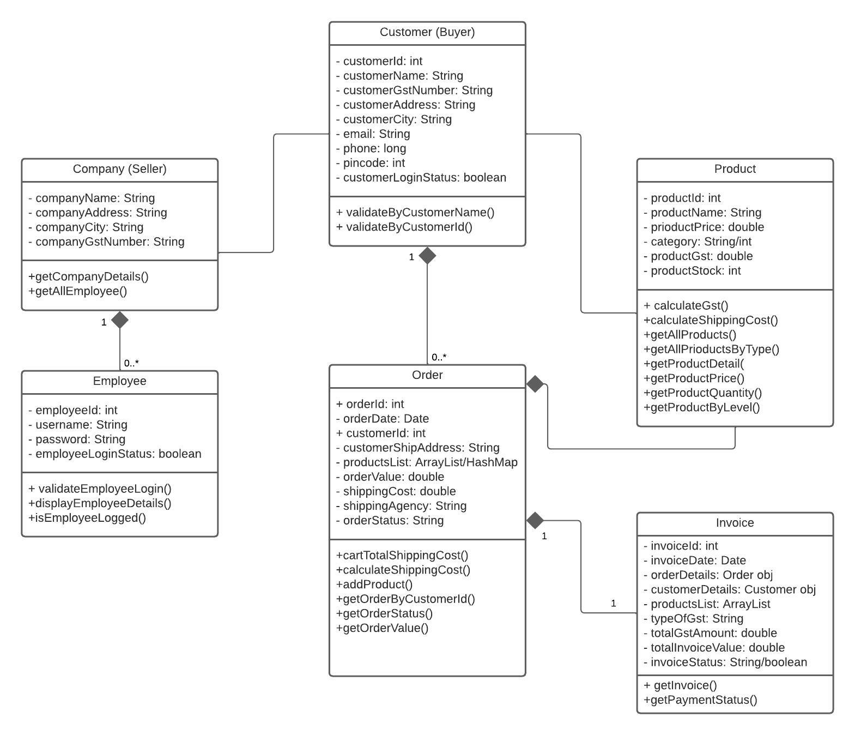

ER Diagram

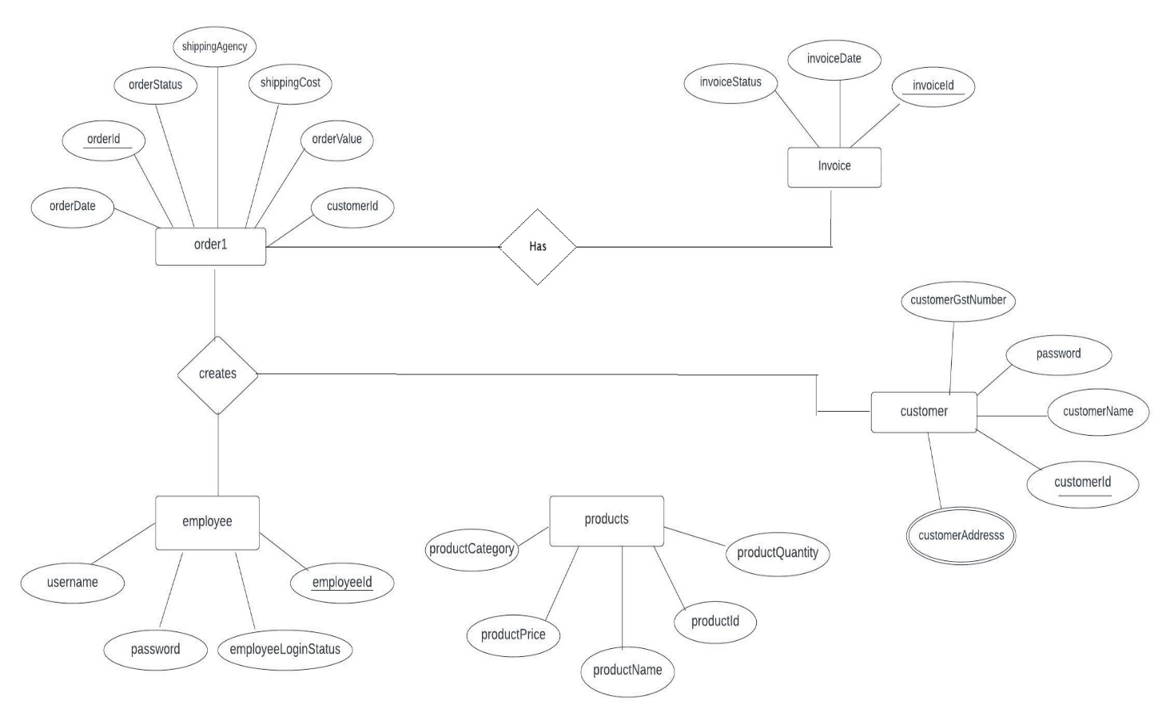

Description:

- The small customers (Individual customers) can create orders for themselves. They can create ORDERS.

- The large customers (large companies with large requirements) are suppose to accept the quotes employees. Here the employee makes the ORDERS.

Use Case Diagram

